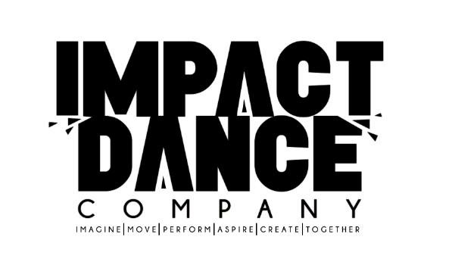

Rob will be holding auditions for Impact 1 on Weds 21st September in Phoenix at 5 pm

It is our hope to continue the excellent work undertaken this year with recruitment of people to this company who can work more intensively and with greater complexity

IF you would like to be considered please arrive for a 5 pm start

You will need to wear trainers
Rob will teach candidates a phrase in “ street style “ which will address the need to work with rhythm and complex coordination.

The audition fee is £5

He would welcome students form current Company classes or newcomers with experience.

Impact 1 is by audition and mostly caters for students from year 9 upwards and Impact 2 will cater for younger students or for those who need to build up confidence and skill in this style

